**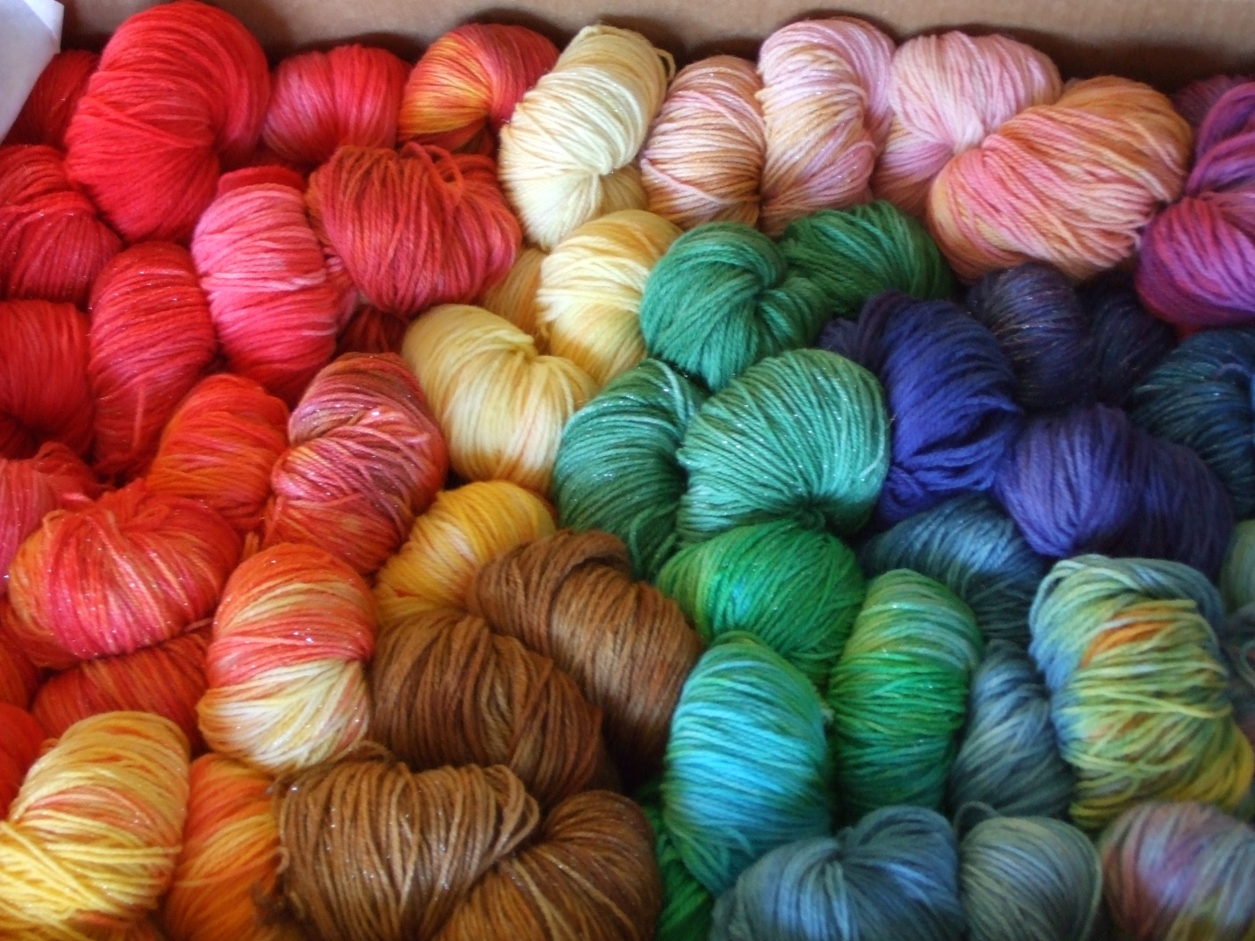**

Healing Circles 2016

Crochet & Knit Workshop

**Knitting & Crocheting for Grief; Support for Death Loss of a Child**

Children’s Hospital is partnering with TRU Community Care and two Healing Circles bereaved PEDS parents who have found the healing powers of knitting and crocheting. Children’s will host a knitting and crocheting workshop for all interested families to come learn how to use these skills to cope with the stresses and heavy feelings of grief**.**

**Date:** Saturday, April 30th

**Time:** 9:30 am- 12:30 pm

**Location:** Children’s Hospital

13123 East 16th Ave

Aurora, CO 80045

**Register:** Michon Davies at TRU Community Care

(303) 604-5330 or

Cassie at Children’s Hospital cassandramatz@childrenscolorado.org

***RSVP by April 15th***

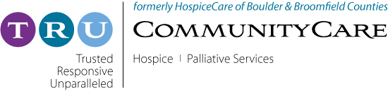

Description: CHC_Logo_E-Mail_Color.jpg